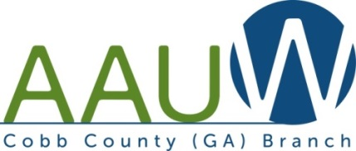

AAUW of Cobb County 2017 Fall Newsletter

AAUW Cobb October Branch Meeting Recap:

With hurricane and tropical storm warnings in September, the first meeting of the year for AAUW Cobb was postponed until Thursday, October 12th. Our Hospitality Chair, JoRae Dahl and her daughter, Denise, provided a wonderful smorgasbord of assorted refreshments for our gathering time before the meeting.
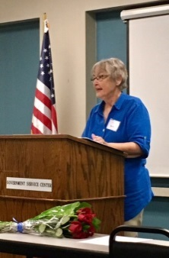
This was a special membership program honoring Sylvia Goodyear’s 50 year membership and we were honored as she shared her memories of AAUW through the years. Sylvia was presented with an AAUW 50 year certificate and pin as well as a bouquet of red roses with a card.

Membership directories were distributed at the meeting to those present and the remaining directories were mailed to those unable to attend. Bea Piddock, AAUW Cobb President, announced that everyone is on the membership committee and talking points were distributed as well as a list of membership anniversaries (from 1 to 30 years) for the branch.
Debbie Karvey provided a recap of the national convention this June in Washington, DC. The memorable highlights shared were Lobby Day at the Capitol and closing banquet dinner with guest speaker, Justice Sonia Sotomayor.
The proposed annual budget was distributed by Amy Stevens followed by an open discussion and comments. The budget was approved as amended.
Although final figures will not be complete until the end of October, Debbie stated we had another successful fundraiser book sale at Perimeter Mall with Cobb volunteer hours earning 18% of the proceeds for the branch. We are fortunate to have our membership contribute their time so generously to the book fair throughout the year and at the sale.
We lost a dear friend and longtime AAUW member, Pam Flournoy this fall. To honor her, the branch donated $100 to the Northwest YWCA LiveSafe Shelter.

1

UPCOMING CALENDAR EVENTS:
Roving Gourmet:
Friday, November 3rd at 7:00 PM
Top Spice Thai/Malaysian Cuisine
2997 Cobb Parkway, Suite 200
Atlanta, GA 30339
770-988-9007
Contact Debbie Karvey by Thursday, 11-2, if you plan to attend.
debbiedah@msn.com / 678-520-2231
Book Fair Celebration:
Sunday, November 12th from 2:00 – 4:00 PM
Marlow’s Tavern
1317 Dunwoody Village Pkwy, Suite 102
Dunwoody, GA 30338
770-559-7528
For our dedicated book fair volunteers to celebrate another successful fundraiser
Please RSVP with Yetta McMillan / yettacmillan@att.net or 678-596-5721

November Branch Meeting: Organized by Book Discussion Group
Tuesday, November 14th
East Cobb Government Center
4400 Lower Roswell Road
Marietta, GA 30062
7:00 PM: Refreshments
7:30 PM: Program: Women in the Justice System
Guest Speaker: M Faye McCord, Attorney

Book Discussion:
Monday, November 20th at 2:00 PM
ECGC Small Meeting Room
1984 by George Orwell
Debbie Karvey will lead the discussion and provide refreshments.
Please let Bonnie Williams know if you plan to attend:
bonniebw41@att.net or 770-971-6130.

Second Saturday: Bookroom Cobb Crew
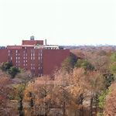
Saturday, December 9th
10:00 AM to 1:00 PM
3060 Pharr Court North NW
Atlanta, GA 30305
404-261-7646
Volunteer/Sort in Bookroom
1:00 PM Lunch outing in Buckhead area
Please let Debbie Karvey know if you plan to attend and want to carpool
debbiedah@msn.com / 770-591-7956 ... carpool meets at 9:30 at ECGC 2
December Branch Holiday Event
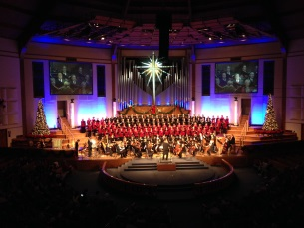
Christmas Concert / Dinner in Roswell
Sunday, December 10th
RUMC Christmas Festival Concert at 3:00 PM
Tickets are free, but must be ordered in advance (by Nov. 6th)
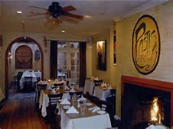
Contact Barbara Blue blubr16@gmail.com / 404-971-0988

Holiday Dinner gathering at Pastis at 5:30 PM
Please let Barbara Blue know if you plan to attend the dinner

Book Group Holiday Dinner / Exchange
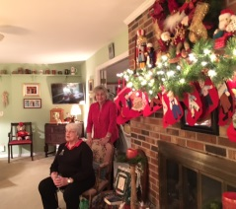
December 18th at 6:00 PM
Home of Barbara Hammond
2430 Weatherford Court
Marietta, GA 30068
Book exchange / potluck share
RSVP: bhammond@kennesaw.edu

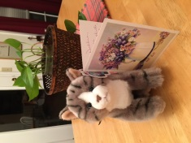
SPECIAL NOTE: I was very touched by the lovely gifts and heartwarming card during the October meeting. The kitty is a sweet reminder of my feline companion, Schweety, who recently crossed over the rainbow bridge. I want to thank everyone for your embrace of friendship. The Cobb team and members are my Georgia family and sisters. It is very special to be part of this group of amazing women and friends. We rock!!!!
Debbie

Please continue to keep Peg Montgomery and Joan Zenteno in your thoughts and prayers as they face health challenges and recovery that will return them to our fellowship.

AAUW PUBLIC POLICY AND COBB ADVOCACY
As discussed in the October meeting, at AAUW National Convention two resolutions related to public policy were approved by the membership for action:
- ERA
- Human Trafficking
We will examine how Georgia members can become involved in advocacy coalitions and issues.
With the implementation of the FCA (Family Care Act) in July, 2017 ... we are now focused on providing support as questions and concerns arise in businesses impacted by the new law: businesses with 25 or more employees, employees who work 30 or more hours a week, employees with earned sick time can take up to 5 calendar days to care for immediate family.
Stay tuned for new updates as the 2018 legislative session starts in January. 3
BRANCH PROJECTS:
- 8TH Grade Girls Essay Contest Task Force
- 2018 Scholarship Task Force
- Bookfair year round volunteer hours
- Public Policy/advocacy opportunities at capitol or special events

Many of our members have enjoyed working on our special projects.
If you are interested in being part of this dynamic outreach to our middle school girls in Cobb County, please let Nancy Coakley know. Planning sessions will begin in January with essay reviews in March and presentation of the awards at our April meeting.

Working on the scholarship task force incorporates campus outreach to financial aid offices and contacts, online submissions through branch website, with review of applications in April and presentative of scholarship recipients at the May dinner meeting. Scholarship task force will be announced at the November meeting.

For our annual Bookfair fundraiser we collect books all year. There are many ways members can contribute by collecting books from drops or helping with special pick-ups, sorting books in the bookroom, participating in Second Saturday Cobb Crew events and working during the book sale. Let us know how you would like to help

Identifying key issues to address in the upcoming 2018 Georgia General Assembly are both proactive and reactive. As issues become prioritized we will let you know what events and/or meetings will be important for members to attend to support an issue or protest a potential bill. Our advocacy work falls in line with AAUW public policy.
Attending hearings, talking to legislators / working the ropes at the capitol as well as attending coalition events in the area are just a few of the ways to be involved.
Updates will be provided ... there is lots of opportunity. Participation in AAUW Action Alerts is also a great way to support advocacy. We will keep you posted.

4

